Assets

The Foundation's assets, amounting to about 4.1 billion euros, are invested as profitable and sustainable as possible. The Foundation is economically independent and autonomous in its decision-making. Apart from financing the Foundation’s ongoing operations, the investments of the Foundation capital pursue above all two objectives: The first one is to secure funding for research on a continuous basis, while the second is to maintain the real value of the Foundation’s capital.

Strategy
The proceeds from the conversion of the Volkswagenwerk to a joint stock company at the beginning of the 1960s formed the starting capital of the Foundation; these were equivalent to a good 0.5 billion euros.
The capital of the Foundation meanwhile amounts to 4.1 billion euros and could thus be more than eightfold. The Foundation manages this capital on an autonomous basis.
The money expended on funding derives from the investment of these assets; it also includes the countervalue of the profits from some 30.234.600 VW ordinary shares held by the State of Lower Saxony. In terms of the volume of funding granted, the Volkswagen Foundation is the biggest institution of this kind in Germany.
Investment Management Objectives
The Foundation is economically independent and thus autonomous in its decisions. Apart from financing the Foundation’s ongoing operations, the investments of the Foundation capital pursue above all two objectives: One is to secure funding for research on a continuous basis, while the second is to keep the real value of the Foundation capital intact.
The fact that the Foundation is oriented to sustained existence prohibits it from touching the Foundation capital to provide the means for funding. It is therefore exclusively the current income from the investment management that is used for this purpose. To ensure that such income maintains at least a constant figure in terms of its material counter-value, the assets of the Foundation must be protected against certain risks such as for example inflation-induced devaluation. This is achieved by forming reserves from a part of the annual proceeds – a measure permitted by law – as well as by generating growth in value.
Earnings-Oriented and Risk-Conscious
The investments of the Foundation’s assets are therefore based not only on interest-bearing securities, but also on stocks and real estate as well as alternative investments. It is these that additionally contribute to maintaining the real value of the assets through their ongoing growth.
The capital is invested in accordance with the principles of the portfolio theory: the more broadly the individual risks and thus also the chances are spread through the choice of the kind of investment, the better secured is the overall success. In this way, the Foundation exploits the risk diversification effect.
This investment strategy ensures the Foundation a successful asset management – not only earnings-oriented, but also risk-conscious – corresponding to the objectives of the Foundation as set forth in its Statutes.
At the end of the 1980s the Foundation set up an Investment Advisory Committee to advise the Foundation on its investment strategy as well as on evaluating the results achieved.

Equity Investment
We also adhere to the principle of the portfolio theory when investing on the stock market. Here too, the objective is to spread the risks and chances on a broad basis in order to achieve a steady increase in value.
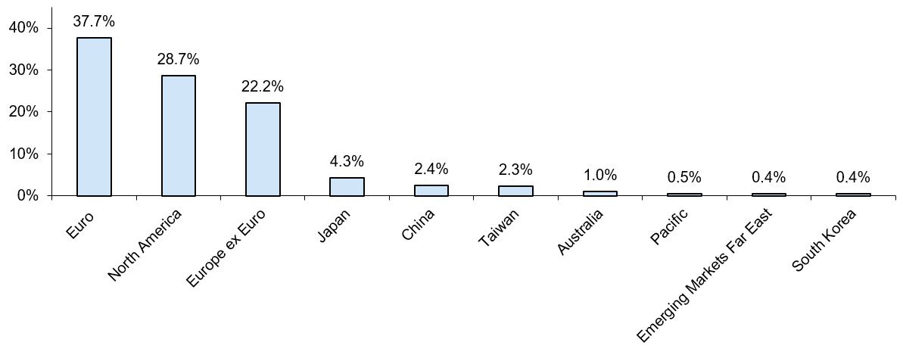
Investment in Shares by Countries (December 2024)

At present, equities make up 49 % of the disposable Foundation's assets. Of these, around 38 percent are shares in companies from Euro area countries. The other assets are distributed among shares from the USA, Canada, the countries of Europe outside of the Eurozone, various countries in South-East Asia and also in the Pacific region. In this case, external mandates for special funds have been given to various financial investment management companies.
In the interest of diversification, when investing in equities the Volkswagen Foundation attaches paramount importance to being present in markets of different geographical regions. The investments of the Foundation in equities are structured by separate portfolios for the individual market segments. Each portfolio is assigned a certain benchmark. These benchmarks contain typical indices for the corresponding investment sectors, which reflect their development and serve as measures of performance for individual markets.
A passive management approach was selected for most of the special funds, as also for the stock holdings managed by the Foundation itself. Here the fund management is set the task of achieving the corresponding benchmark. Possible negative market trends are taken into account, as these are generally compensated by positive trends elsewhere in the Foundation's portfolio. On aggregate this results in a smoothing of the fluctuations in value accompanied by reduced risks. An exception is a portfolio that contains European Small, Mid and Micro Caps and is managed actively.
For the special fund mandates, mainly benchmark indices were chosen that pay particular attention to ecological and ethical as well as good corporate governance criteria in the selection of their individual securities. In addition, the Volkswagen Foundation reserves the right to refrain from certain investments in individual cases.
When selecting shares for its own portfolio, the Volkswagen Foundation applies its own sustainability criteria. These include both exclusion and positive criteria, and aspects of the UN Global Compact are also taken into account. The Volkswagen Foundation regularly receives corresponding evaluations from an ESG research agency.
All the Foundation’s financial assets – in the direct portfolio as well as in the special funds – are subjected to an ex-post analysis with regard to comprehensive ESG criteria. In this respect, a key determinant provides information on the extent to which a portfolio meets the defined criteria.

Interest-bearing Securities
About 40 per cent of the Foundation's assets are nominal values and can thus be categorized as interest-bearing securities. The traditionally rather high share of nominal values ensures a regular income that can be planned and is generally associated with low risk. That is especially important for providing funds which are financed exclusively from ordinary income. Furthermore, this approach avoids large price fluctuations and depreciation.

Interest-bearing Securities (December 2024)
The nominal values are managed in-house, another part by two special bond funds. The volume of the in-house managed titles amounts at the moment to 1,346 million euros, the volume of the special bond funds to 860 million euros. Besides a liquidity position that is held in the form of account balances, overnight money and short term money as well as short term bonds, the self-administered securities include corporate bonds, mortgage bonds, public sector bonds, and subordinated securities. A breakdown of the in-house managed securities can also be seen from the diagram above.
The basis of the investment in securities is a semi-active approach in connection with a "steady hand" investment policy. The objective is to achieve the highest possible, and yet safe current interest, while price gains achieved by regroupings of assets do not constitute a major objective. The advantages deriving from this strategy are continuously checked out by means of benchmarking and total return concepts.
Both bond funds are managed actively and with the aid of quantitative models. One mandate contains New Zealand, Canadian, Norwegian and Australian government bonds, each denominated in the corresponding national currency. The second external mandate comprises US government bonds, US corporate bonds and emerging markets bonds.
The aspect of sustainability is also becoming increasingly important for interest-bearing securities. This area is therefore also regularly subjected to a comprehensive examination, in which a corresponding valuation coefficient is determined by incorporating a large number of defined sustainability criteria. This ensures continuous optimization regarding the sustainability of investments.

Real Estate Investments (Zahlen per 31.12.2024)
The diversification principle also rules in the property sector. Just like shares, real estate investments are supposed to protect the investment against inflation risks. At the same time, the income from rents is a major component for earning current income and making funds available for research. Both aspects contribute to the important role played by real estate within the framework of the overall portfolio.

Real Estate Investments by Countries (December 2024)

Within the real estate sector, the diversification of risks is achieved through a geographical spread of the investments. The historically grown focus of these investments lies within Germany. The German properties are held via subsidiary companies that are externally administered and that are supported and controlled by the Foundation. The properties in question are residential and office buildings located all over Germany. These are supplemented by two office buildings that have been let to scientific institutions in London and Washington and that are also owned by subsidiary companies of the Volkswagen Foundation. Also provided by a subsidiary was the reconstruction of the Herrenhausen Palace in Hanover. The palace is leased to external operators as a museum and as a conference centre.
The European real estate investments are concentrated in the Foundation's special fund. The investments of the fund – exclusively in office buildings – have been spread over France, the Netherlands, Belgium, Luxembourg and Spain.

